ASSIGNMENT - 13

**CSP - 554 BIG DATA TECHNOLOGIES**

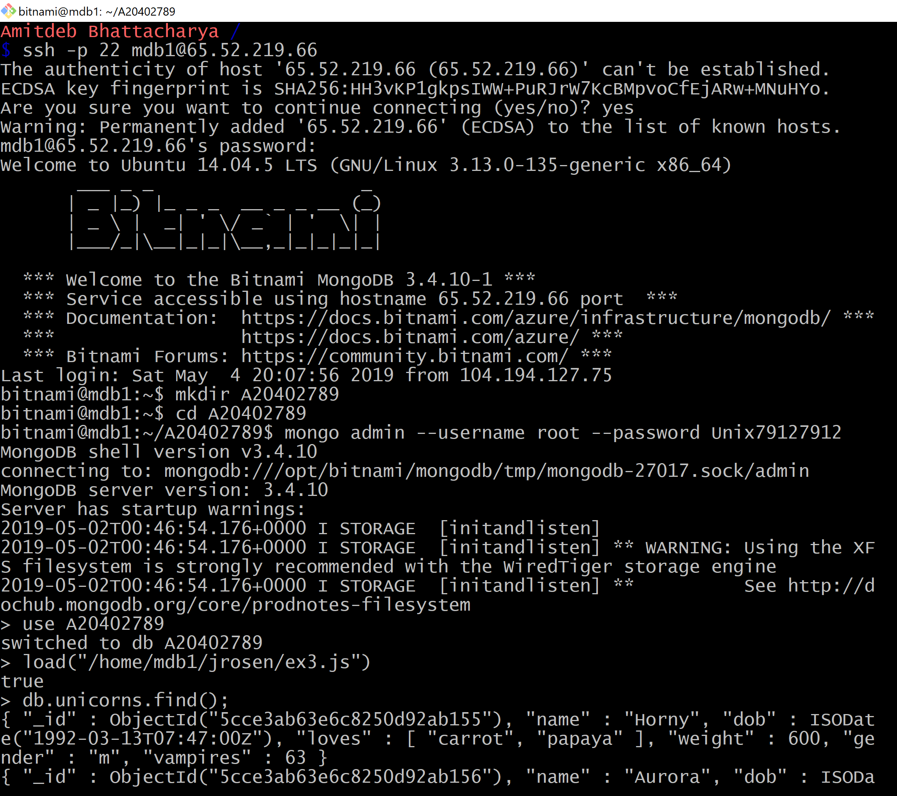

## 

## Exercises

Exercise 1)

Write a command that finds all unicorns having weight less than 500 pounds. Include the code you executed and some sample output as the result of this exercise.

**Command:** db.unicorns.find({weight:{$lt:500}})



Exercise 2)

Write a command that finds all unicorns who love apples. Hint, search for “apple”. Include the code you executed and some sample output as the result of this exercise.

**Command:** db.unicorns.find({loves:”apple”})

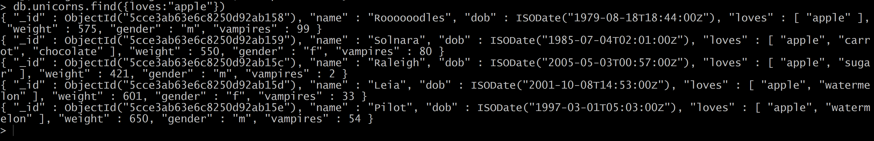

Exercise 3)

Write a command that adds a unicorn with the following attributes to the collection. Note dob means “Date of Birth.”

|  |  |
| --- | --- |
| Attribute | Value(s) |
| name | Malini |
| dob | 11/03/2008 |
| loves | Pears and grapes |
| weight | 450 |
| gender | F |
| vampires | 23 |
| horns | 1 |

Include the code you executed to insert this unicorn into the collection along with the output of a find command showing it is in the collection.

**Command:** db.unicorns.insertOne({name:”Malini”, dob:”2008-03-11”, loves:[”pears”,”grapes”], weight:450, gender:”F”, vampires:23, horns:1})



**Command:** db.unicorns.find();

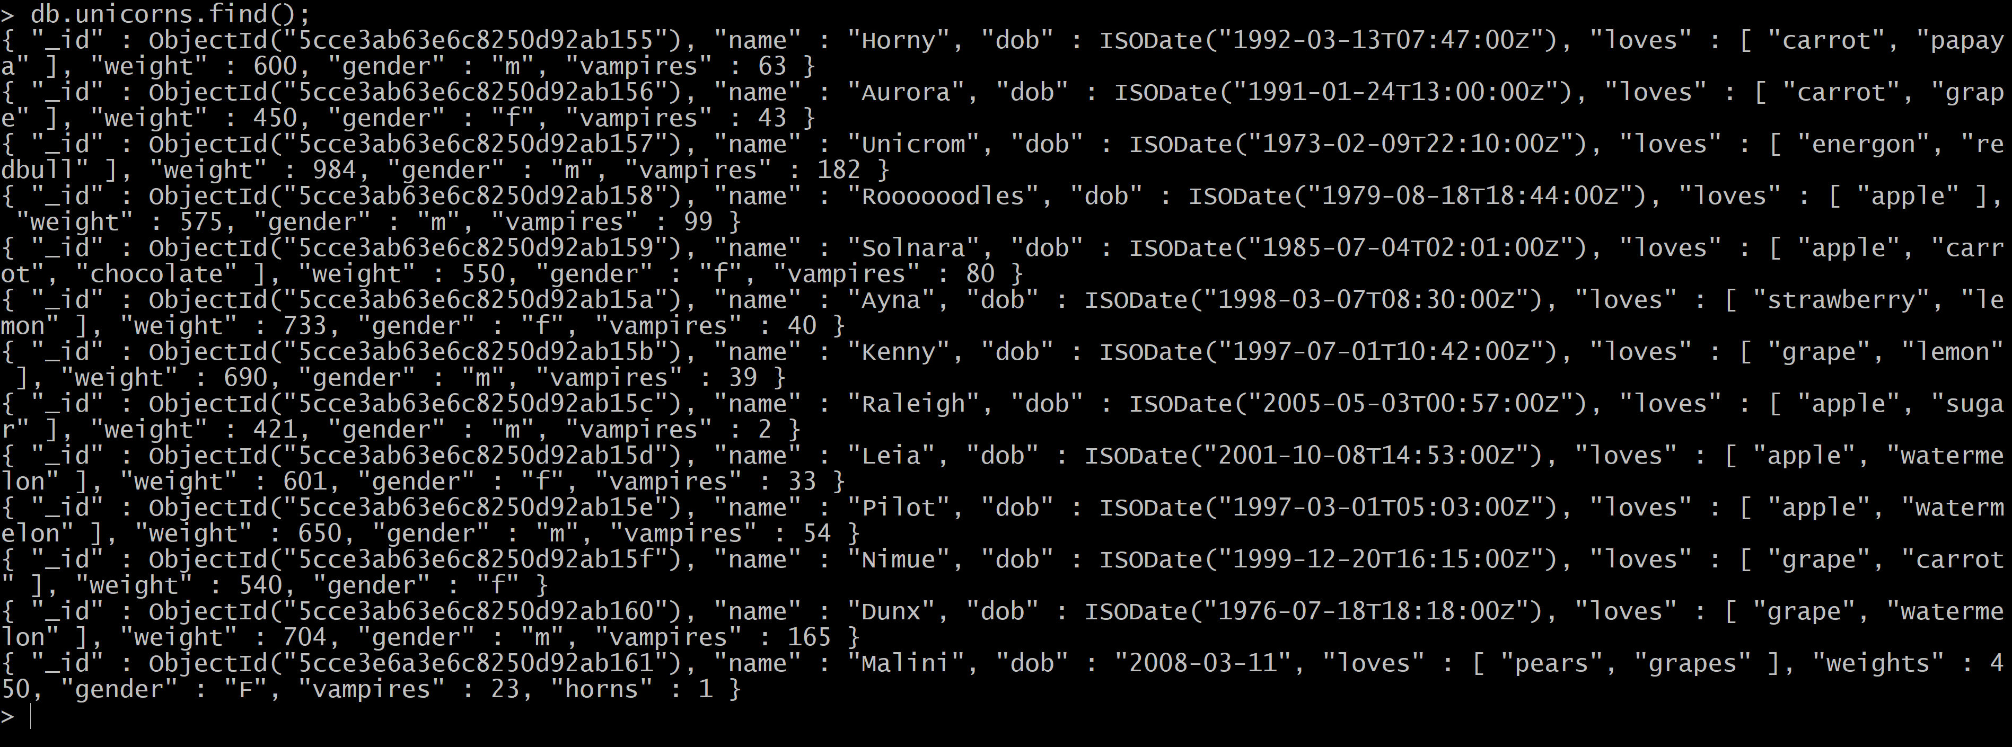

Exercise 4)

Write a command that updates the above record to add apricots to the list of things Malini loves. Include the code you executed and some sample output showing the addition.

**Command:** db.unicorns.updateOne({loves:[“pears”,”grapes”]},{$set:{loves:[“pears”,”grapes”,”apricots”]}}



**Command:** db.unicorns.find(name:”Malini”);



Exercise 5)

Write a command that deletes all unicorns with weight more than 600 pounds. Include the code you executed and some sample output as the result of this exercise.

**Command:** db.unicorns.deleteMany({weight:{$gt:600}})

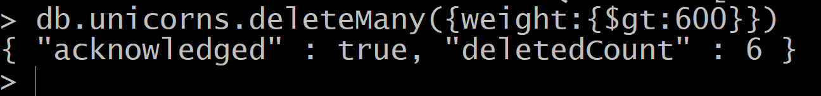

**Command:** db.unicorns.find();

